Setting up your writing environment

# Purpose

This resource will help you configure your computer so that you can easily create, update and share new learning resources for your course. This is achieved by creating a shared folder (directory) on your computer that contains all the learning resources for your course. Once the folder is created, you will be able to use Word, PowerPoint and other desktop applications to more easily curate an engaging online learning environment in Learning@Griffith (Blackboard).

### What you will do

To create the shared folder, you will need to complete three steps

1. Preparing – check you have the necessary information and software.
2. Connecting – the shared folder to your computer (should only need to be done once).
3. Disconnecting –from the course shared folder if you are no longer involved.

How to use this shared folder to curate the learning environment in Learning@Griffith is handled in other resources.

**It’s just not useful for learning resources**

The technology used here is called [*OneDrive*](https://en.wikipedia.org/wiki/Microsoft_OneDrive). It is a Microsoft technology for sharing information via network drives and the cloud. It is Griffith University’s accepted standard for network drives. You can (perhaps already are) using OneDrive to sync resources for other purposes on your computer to the cloud.

# Preparing

This step aims to prepare you and your computer for connecting to the shared drive. It involves the following steps

1. Gathering – the necessary information you need for this to work.
2. Checking – if you already have the OneDrive sync application installed.
3. Installing - the OneDrive sync application, if it’s not.
4. Finding – where one your computer the application is syncing to.

## Gathering

To connect the OneDrive sync application you will need answers to the following questions.

1. What is your Griffith University username (you S number), password, and email address?  
   As with all Griffith University IT services, your S number and password [are required to gain access](https://intranet.secure.griffith.edu.au/computing/account-management/access-to-services).
2. What type of computer do you have (Windows or Mac)?
3. What version of your operating system are you running?
   1. [Which version of Widows](https://www.lifewire.com/what-version-of-windows-do-i-have-2624927) are you running?
   2. [Which version of Mac OS X](https://support.apple.com/en-au/HT201260) are you running?
4. What is the URL for the shared folder containing your course materials?  
   This will be provided either directly to you or may be available from the *Course Administration* section on your course site.

**For the Mac you will need Mac OS 10.12 or newer**

Currently, installing OneDrive on a [Mac computer requires](https://support.microsoft.com/en-us/office/sync-files-with-onedrive-on-mac-os-x-d11b9f29-00bb-4172-be39-997da46f913f) that you have at least Mac OS 10.12 or newer.

If you do not, it may be necessary to upgrade.

## Checking

The OneDrive sync application is the software application that will manage the synchronisation of changes between the files on your computer and the versions that are in the cloud. It needs to be installed.

**It may already be installed if…**

If you are using

1. A Griffith University computer; or,
2. A Windows 10 computer.

Work through the following steps to identify if you have it installed, and, if you don’t install it.

### Login to https://office.com

Use a web browser to visit and sign in to <https://office.com> using your Griffith email address.

Enter your Griffith S Number and password as requested.

You should see a web page that includes something like Figure 1.

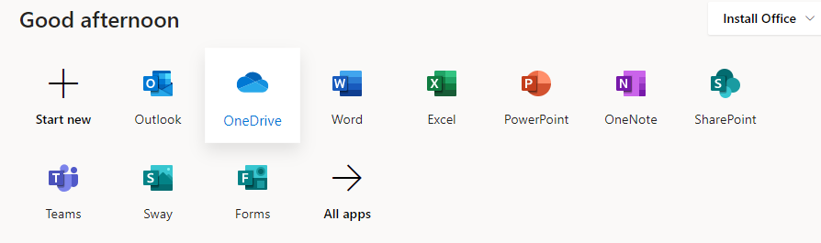

Figure 1 - Part of the Office.com web page

### Go to OneDrive and start a sync

Click on the OneDrive icon (as shown in Figure 1) to view the contents of your OneDrive.

Click on the **Sync** button as highlighted in Figure 2.



Figure 2 - Highlighting the OneDrive sync button

Check that a **Getting ready to sync…** window appears as shown in Figure 3.

Figure 3 - The "getting ready to sync" window

### Did a sync commence?

When you start a sync there you may see one of three results:

1. A window asks if you’d like to *Open Microsoft OneDrive*.  
   If you agree, then syncing may commence (Congratulations, you have the OneDrive sync application installed), or you may find the next result occurs.
2. A message appears suggesting that you are already syncing *OneDrive – Griffith University*.  
   Congratulations, you have the OneDrive sync application installed.
3. Nothing happens.  
   Sorry, this suggests that you do not have the OneDrive sync app and you need to complete the next step

## Installing

If a sync did not commence, then it is likely you do not have the OneDrive sync app installed.

To install the app, click on the [*get the latest version of OneDrive* link](https://go.microsoft.com/fwlink/p/?LinkId=248256). Either here or in the “getting ready to sync” window (as shown in Figure 3).

This will start the process to download an installer for the OneDrive sync app. Once downloaded, you will need to…

### Run the downloaded file

Once the file is downloaded it needs to be run (this may happen automatically) in order to configure the OneDrive sync application. To configure the application you will need to use your Griffith University email address and S Number/password.

Run the downloaded file and follow the instructions. For more information, try the following:

* [Configuring OneDrive sync app for Windows](https://support.microsoft.com/en-us/office/sync-files-with-onedrive-on-mac-os-x-d11b9f29-00bb-4172-be39-997da46f913f#bkmk_noaccountsignedin).
* [Configuring OneDrive sync app for Mac OS X](https://uit.stanford.edu/service/office365/online-and-onedrive/mac).

**Testing out the installed application**

Once you’ve finished installing the OneDrive sync application, you may want to repeat the process above to check that everything is working.

## Finding

When you set up the OneDrive sync application with your Griffith University credentials it should create a folder on your local computer called **OneDrive – Griffith University**. This folder will contain (just about) all of the Griffith University network folders/drives you sync.

To find this folder you can may be able to find it via your *File Explorer* (Widows) or *Finder* (Mac OS) widows. Or, you may wish to use your operating system’s search function.

# Connecting

Congratulations, the OneDrive sync application is installed on your computer. The next stage is to connect the OneDrive sync application to your course’s shared folder. You will do this by:

1. Viewing – your course’s shared folder with a web browser.
2. Syncing – the folder with your computer.
3. Finding – the synchronised folder on your computer.

## Viewing

Use your web browser to visit the URL for your course’s shared folder.

You should see something like Figure 4.

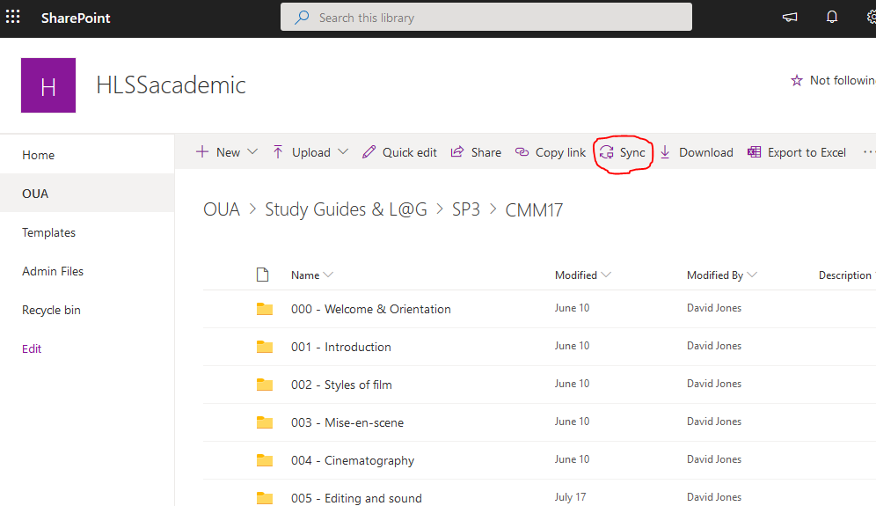

Figure - An example course shared folder viewed via a Web browser

## Syncing

Hit the **Sync** icon (circled in red in Figure 4) to tell the OneDrive sync application to start synchronising a copy of the shared folder on your computer.

You should see something like Figure 5. Where the browser is asking permission to open the OneDrive sync application.

Click **Open OneDrive** and the synchronisation process should commence.

You are now able to start using the browser for other tasks.

Figure - Successful sync request asking to open OneDrive

## Finding

If the sync request is successful, you should now find a new folder within your *OneDrive - Griffith University* folder (see the *Connecting* section above). This folder (e.g. Figure 6) will provide you direct access via your computer to all the files within the folder. Enabling you to use them as you would any other file on your computer. For example, using local computer application (e.g. Microsoft Word etc.) to create and modify files. Any changes you make will be automatically synchronised with the network drive and anyone else using the network drive.

Figure - Course folder sync'd to a Mac computer

# Disconnecting

If you no longer need to work on the shared course folder you can either

1. Stop the synchronisation (disconnect) for a particular folder.
2. Stop the OneDrive sync application.

Either of these is achieved via the settings of the OneDrive sync application

## Open the settings (preferences) of the OneDrive sync application

When the OneDrive sync application is running you will see a OneDrive icon in your computer’s *taskbar* (Windows – see Figure 8) or *menu bar* (Mac – see Figure 7). The OneDrive icon will appear as a small cloud, which has been circled in red in .

|  |  |
| --- | --- |
| Figure - Part of a Mac menu bar | Figure - Part of a Windows task bar |

If you click, right-click or CTRL-click on the OneDrive icon you will be shown a OneDrive menu (e.g. Figure 9). One of the options it includes will be either *Settings* (Windows) or *Preferences* (Mac), click on that option.

Figure - OneDrive app menu (Mac)

## Stop syncing a folder

Having opened the settings for the OneDrive app you will see a new window similar to Figure 10. If you click on the *Account* tab in this window you will see a list of all the folders that the OneDrive application is currently sycnhronising.

Find your course folder and click on the relevant **Stop sync** link.

Figure - OneDrive app settings (Mac)

## Stop the OneDrive sync application

If you would like to stop the OneDrive sync application entirely, then click on the **Quit OneDrive** (Mac) or **Close OneDrive** (Windows) link in the OneDrive sync application menu (Figure 9).